Q-1. Write an SQL query to fetch “FIRST_NAME” from Worker table using the alias name as <WORKER_NAME>.

Ans1 : SELECT FIRST_NAME AS WORKER_NAME

FROM worker;

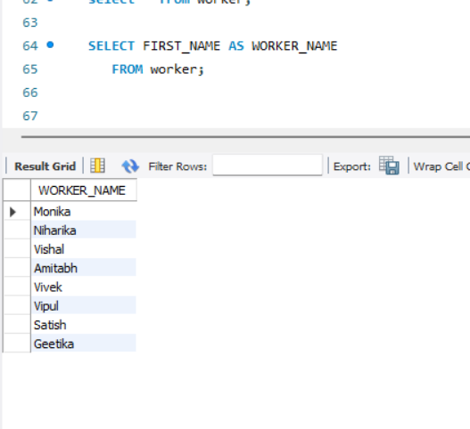

#### Q-2. Write an SQL query to fetch unique values of DEPARTMENT from Worker table.

#### Ans : SELECT DISTINCT(DEPARTMENT)

#### FROM worker;

#### 

#### Q-3. Write an SQL query to show the last 5 record from a table.

#### Ans : SELECT * FROM worker

#### ORDER BY WORKER_ID DESC

#### LIMIT 5;

